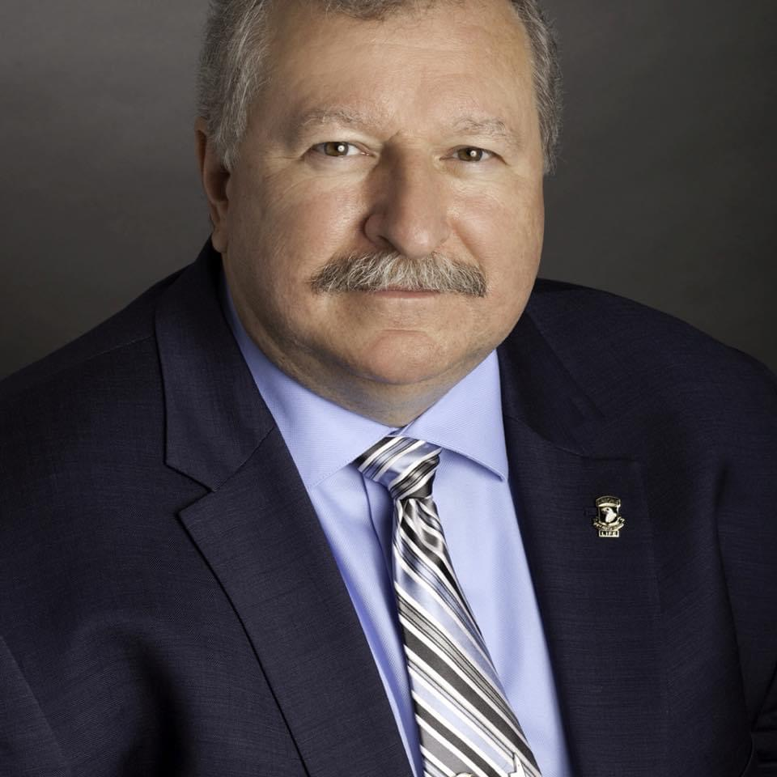

Dominick Kasmauskas
1917 Hutchinson Drive
Kingsport, TN 37660

518-937-4790 Cell
DGKasmauskas@gmail.com

Dominick has a strong belief in the saving of lives, property, businesses, jobs, and our environment from unwanted fires through the proper installation of fire protection systems, along with ITM and timely corrections. This is what gets Dominick up in the mornings. Marketing, sales, and promoting fire protection systems.

Although, now technically retired, Dominick is the Legislative Consultant for the American Fire Sprinkler Association (AFSA) and consultant to SSI Fire Solutions of Canada, an environmentally sustainable fire suppression alternative. From 2021 through 2023, Dominick was the Regional Director of Membership Services & Chapter Support for the AFSA for states in the eastern US and his last year covering all 50. Job 1 was supporting members with their business and construction challenges, technical services, training, plus suggesting legislation and advocating with state and local governments.

Dominick was previously with the Natl Fire Sprinkler Assn for nineteen years using his experience in legislation, codes, and local laws to assist in making the business environment better for fire protection contractors. In 2020 during the supposed pandemic, he consulted for Inspection Reports On Line (IROL).

However, starting from the beginning, Dominick began with the fire service in 1974 in northern New Jersey achieving several years in the officers’ ranks and obtaining certifications in Firefighter I, II, and III, Fire Inspector I and II in NJ as well as National Fire Academy Fire Officer II. He also held certifications as a NJ Fire Instructor I and II, as well as a NJ State Police Hazardous Materials Instructor while employed at the Bergen County (NJ) Fire Academy as a primary fire instructor. Dominick also has experience in law enforcement with the US Army Military Police, two reserve police officer positions in NJ, and is a graduate of the Bergen County Police Reserves Academy. He gained experience in legislative matters with his NJ and Virginia fire service positions and as a volunteer advocate with the Pennsylvania Fire & Emergency Services Institute by promoting not only firefighter issues, but also a team member in the adoption of the first statewide Pennsylvania building code.

Dominick is a former NFPA Certified Fire Protection Specialist® and serves on the NFPA 1031 “Fire Inspector and Plans Examiner” Committee and is a former member of the Board of Directors for the NFPA Fire Service Section. Dominick was formerly a contract instructor for the International Codes Council, served on the ICC International green Construction Code (IgCC®) Energy & Water Subcommittee, and served on the American Water Works Association (AWWA) Fire Protection Committee. Dominick also served on the Board of Directors for the Metro NYC Chapter of the Society of Fire Protection Engineers (SFPE) and is a member of the NY Building Officials Conference, Fire Code Committee. He also regularly attends many industry-relevant events as a presenter and an exhibitor.

Dominick has been awarded commendations in both the fire service and the military as he has also spent four years active duty serving in a HAWK Missile, Air Defense Artillery battery and also 2nd Battalion of the 327th Infantry Regiment, 101st Airborne in the U.S. Army and was awarded the Army Good Conduct Medal and Honorably Discharged in 1980.

